

**Tribhuvan University**

**Faculty of Humanities and Social Science**

**Scripting Language**

**A LAB REPORT**

**Submitted To**

**Department of Computer Application**

**Shahid Smarak College**

*In partial fulfillment of the requirements in the Bachelors in Computer Application*

Submitted By :

Amir Maharjan

TU Regd.No :

Exam Roll No:

_______________

**Internal Supervisor**

**Sandesh Bista**

**_______________**

**External Supervisor**

**Kirtipur, Kathmandu**

**Table of Contents**

Lab 1: Write a JavaScript code to show alert message. 1

Lab 2: Write a function in JavaScript to find the cube of a given number. 2

Lab 3: Write a JavaScript Program for form validation: 3

Lab 4: Write a JavaScript code to find the sum and average of two numbers input by users. 4

Lab 5: Design a simple arithmetic calculator using JavaScript program. 5

Lab 6: Write a JavaScript code to find largest and smallest numbers of an array. 6

Lab 7: Write a PHP program to print following list using array and loop. (Use for each loop and ordered list). 7

Lab 8: Write a PHP program to upload file in PHP with type’s PNG, JPG and GIF. 8

Lab 9: Validate registration form with name, email, age, phone with required and its related type validation. 9

Lab 10: Write a PHP program to send email to user. 11

Lab 11: Write a program to create and connect with database named Student using PHP. 11

Lab 12: Write a program that saves the data of student registration form in the StudentInfo table of Student database. 12

Lab 13: Write a program to update and delete existing record into MySQL database named Student using PHP. 14

Lab 14: Design form in HTML and write corresponding PHP and MYSQL code to store the user’s value after satisfying following validation rules. 15

Lab 15: Write an ajax program to show the name suggestions for any typed letter. 17

Lab 16: Write a jQuery program to show and hide any text according to choices, show button and hide button. 18

# **Lab 1: Write a JavaScript code to show alert message.**

**Objective:** To show alert message.

**Program:**

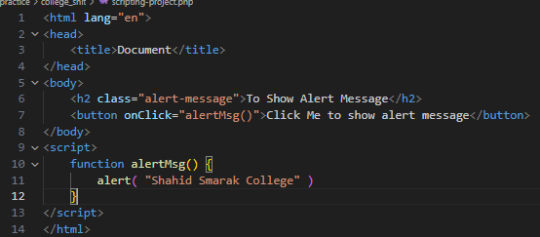

**Output:**

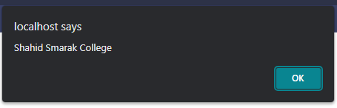

# **Lab 2: Write a function in JavaScript to find the cube of a given number.**

**Objective:** To find cube of a given number.

**Program:**

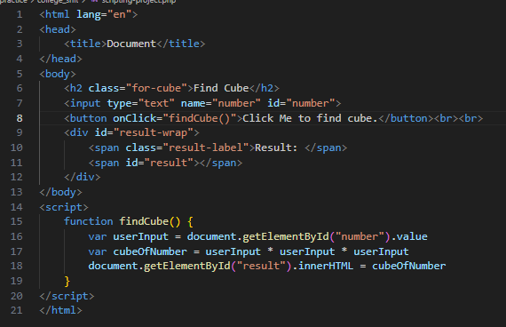

**Output:**

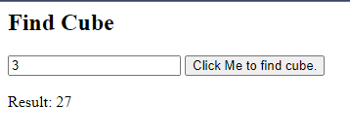

# **Lab 3: Write a JavaScript Program for form validation:**

User Form have name, password, gender and email fields.

**Objective:** To properly validate a form having name, password, gender and email.

**Program:**

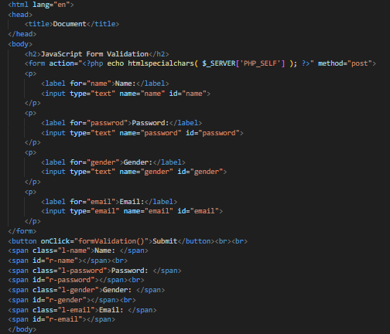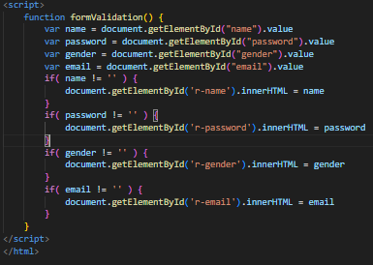

**Output:**

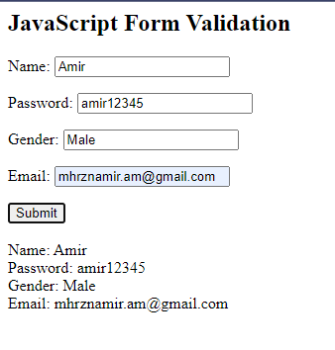

# **Lab 4: Write a JavaScript code to find the sum and average of two numbers input by users.**

**Objective:** To find the sum and average of two numbers input by users.

**Program:**

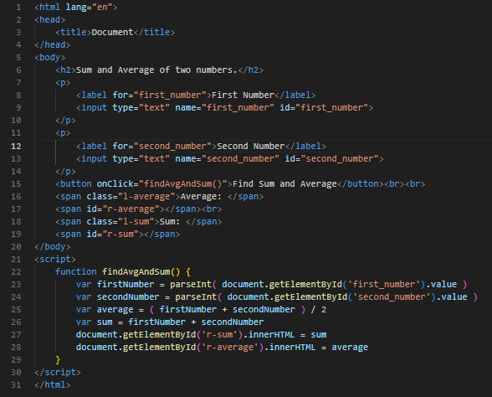

**Output:**

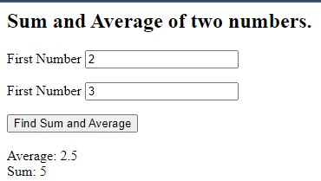

# **Lab 5: Design a simple arithmetic calculator using JavaScript program.**

**Objective:** To design a simple arithmetic calculator using JavaScript.

**Program:**

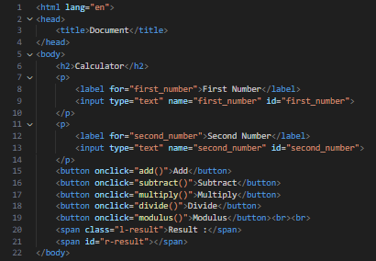

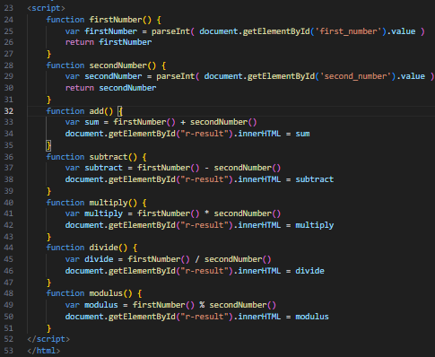

**Output:**

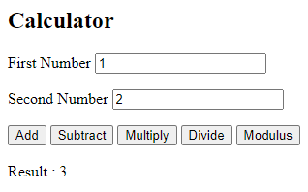

# **Lab 6: Write a JavaScript code to find largest and smallest numbers of an array.**

**Objective:** To find largest and smallest numbers in an array.

**Program:**

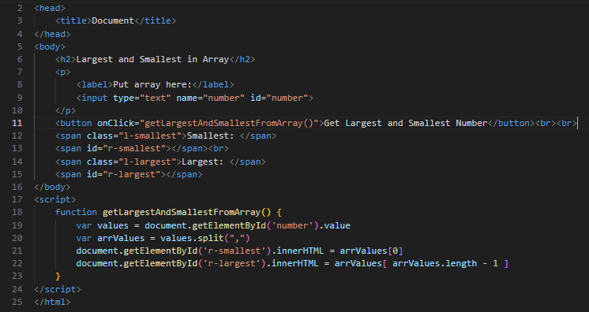

**Output:**

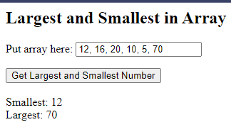

# **Lab 7: Write a PHP program to print following list using array and loop. (Use for each loop and ordered list).**

a. Scripting Language

b. Software Engineering

c. Numerical Method

d. Operating system

**Objective:** To print following list using array and loop.

**Program:**

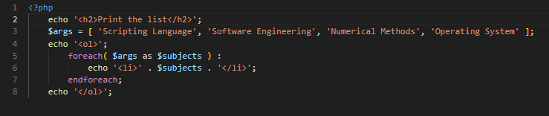

**Output:**

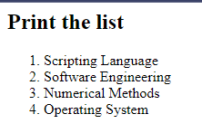

# **Lab 8: Write a PHP program to upload file in PHP with type’s PNG, JPG and GIF.**

**Objective:** To upload file in PHP with type’s PNG, JPG and GIF

**Program:**

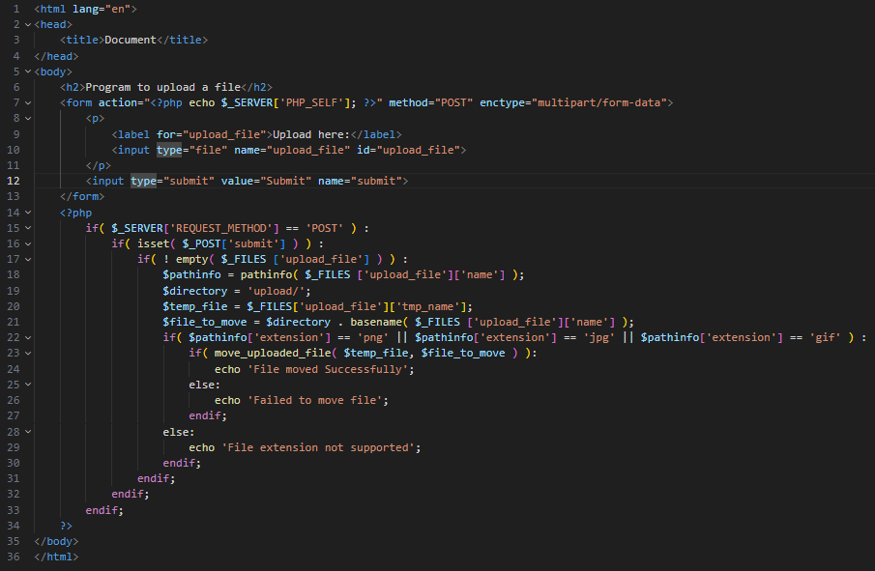

**Output:**



# **Lab 9: Validate registration form with name, email, age, phone with required and its related type validation.**

**Objective:** To validate form with name, email, age, phone in PHP

**Program:**

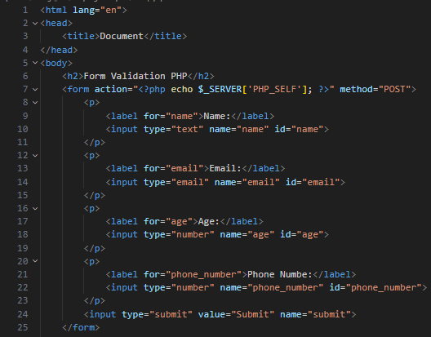 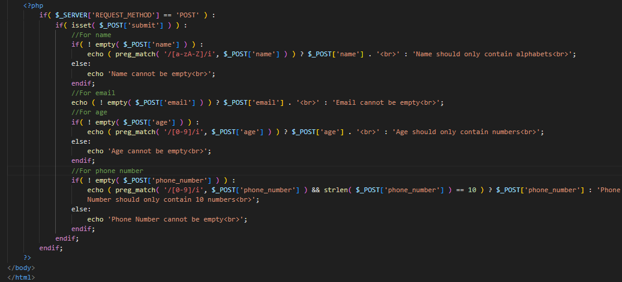**Output:**

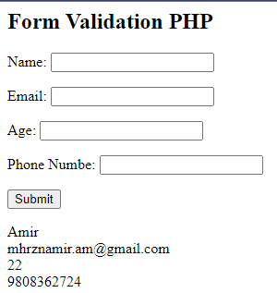

# **Lab 10: Write a PHP program to send email to user.**

**Objective:** To send email to user.

**Program:**

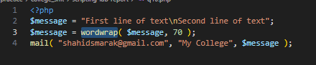

**Output:**

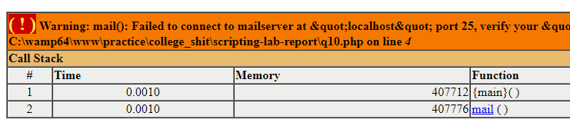

**Lab 11: Write a program to create and connect with database named Student using PHP.**

**Objective:** To create and connect with database named student with PHP.

**Program:**

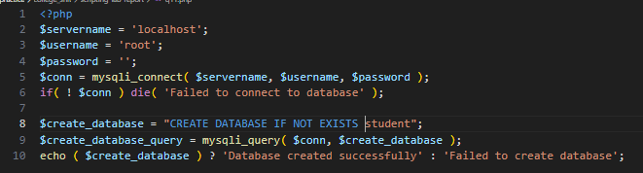

**Output:**

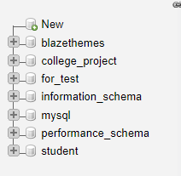

# **Lab 12: Write a program that saves the data of student registration form in the StudentInfo table of Student database.**

**Objective:** To save data of student registration form in *studentinfo* table in student database.

**Program:**

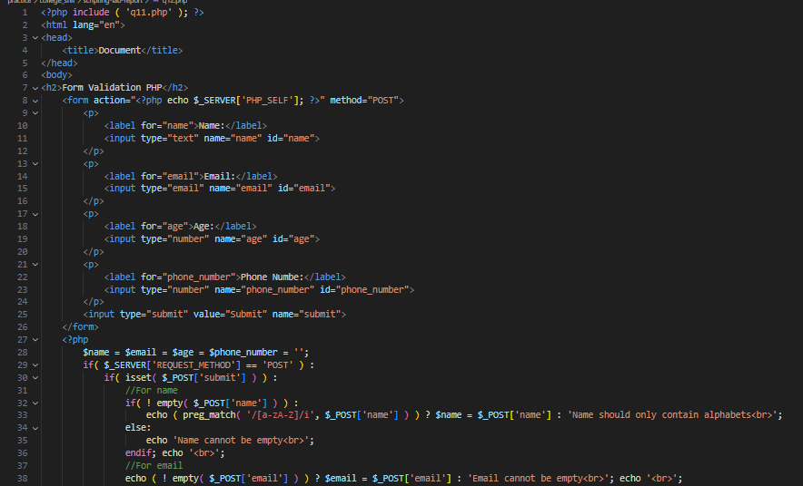

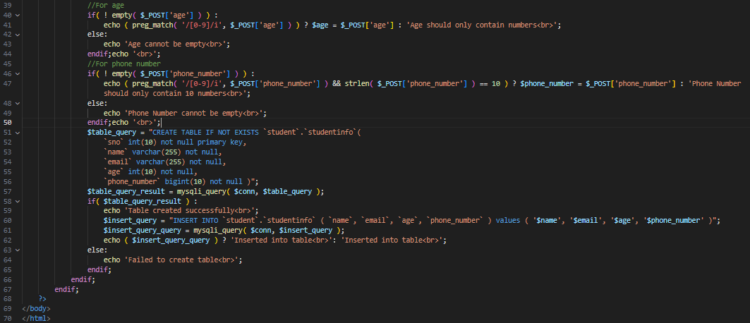

**Output:**

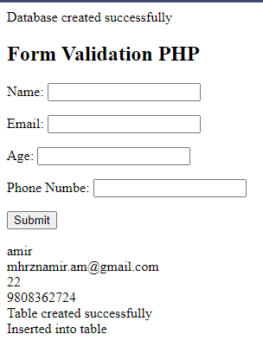

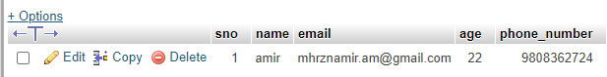

# **Lab 13: Write a program to update and delete existing record into MySQL database named Student using PHP.**

**Objective:** To update and delete existing record into MySQL database student.

**Program:**

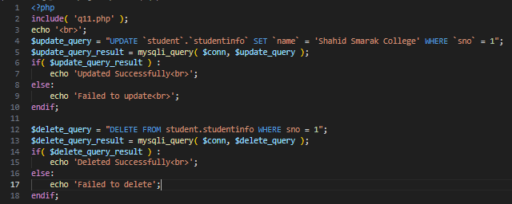

**Output:**

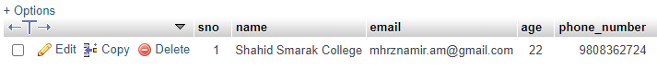 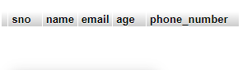

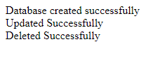

# **Lab 14: Design form in HTML and write corresponding PHP and MYSQL code to store the user’s value after satisfying following validation rules.**

a. Length of Full name up to 40 characters.

b. Email address must be valid email address.

c. Username must be start with string and followed by number.

d. Password length must be greater than 8 characters.

**Objective:** To design HTML and proper form validation.

**Program:**

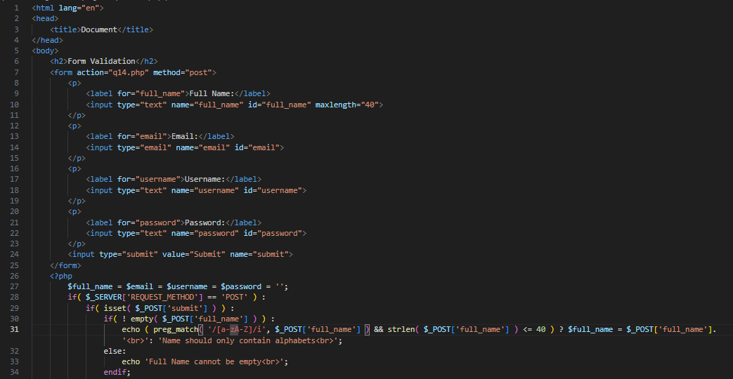

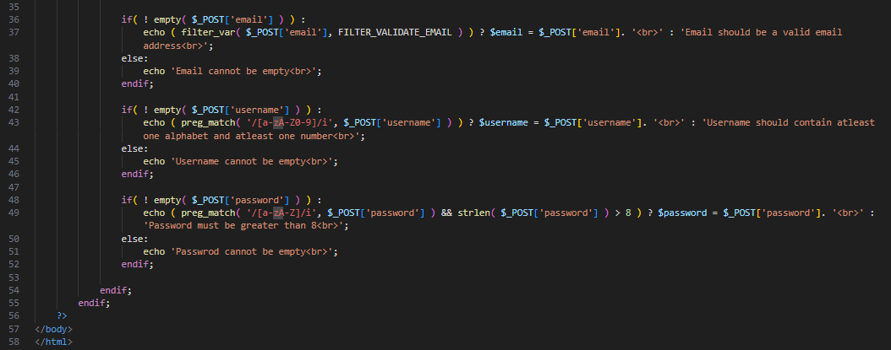

**Output:**

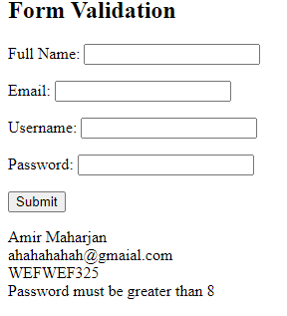

# **Lab 15: Write an ajax program to show the name suggestions for any typed letter.**

**Objective:** To show name suggestions for any typed letter in AJAX.

**Program:**

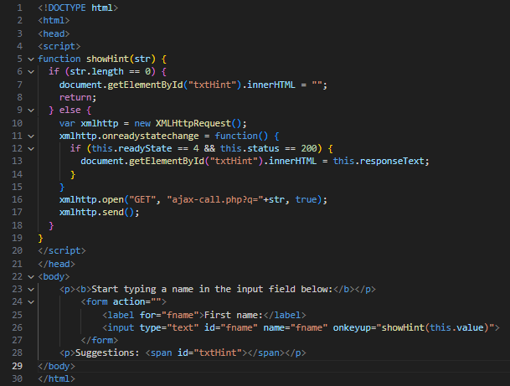

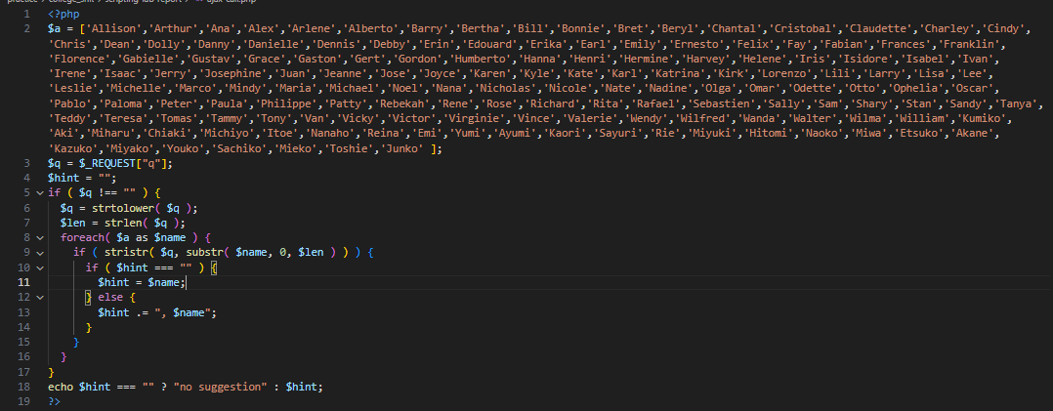

**Output:**

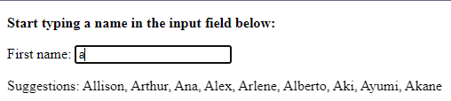

# **Lab 16: Write a jQuery program to show and hide any text according to choices, show button and hide button.**

**Objective:** To show and hide any text according to choices, show button and hide button.

**Program:**

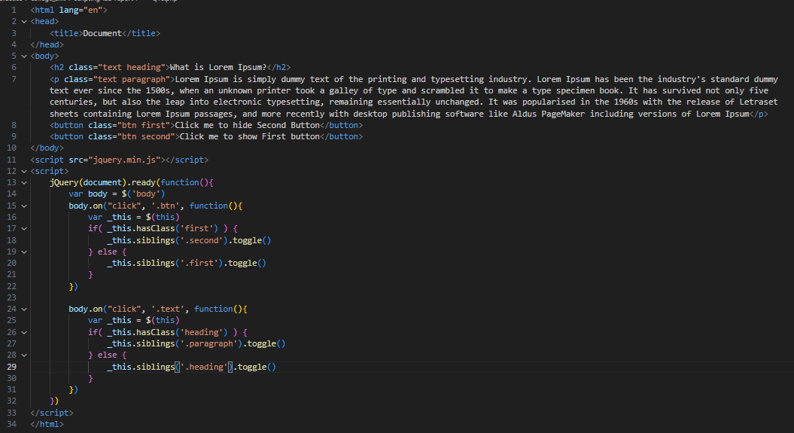

**Output:**

